Buttons-:

This is a button which is used for proceeding for further things in it

General design of this in net beans



Figure 9 design of button

The output display in java

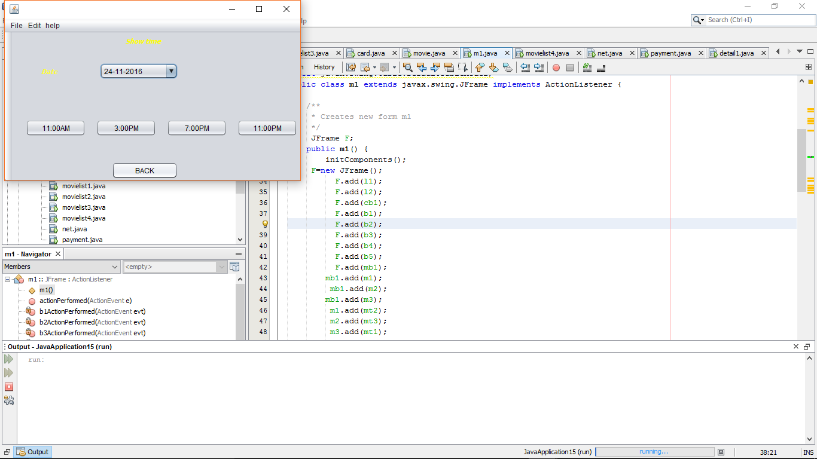

Figure 10 output page

After clicking the back it redirect to another page

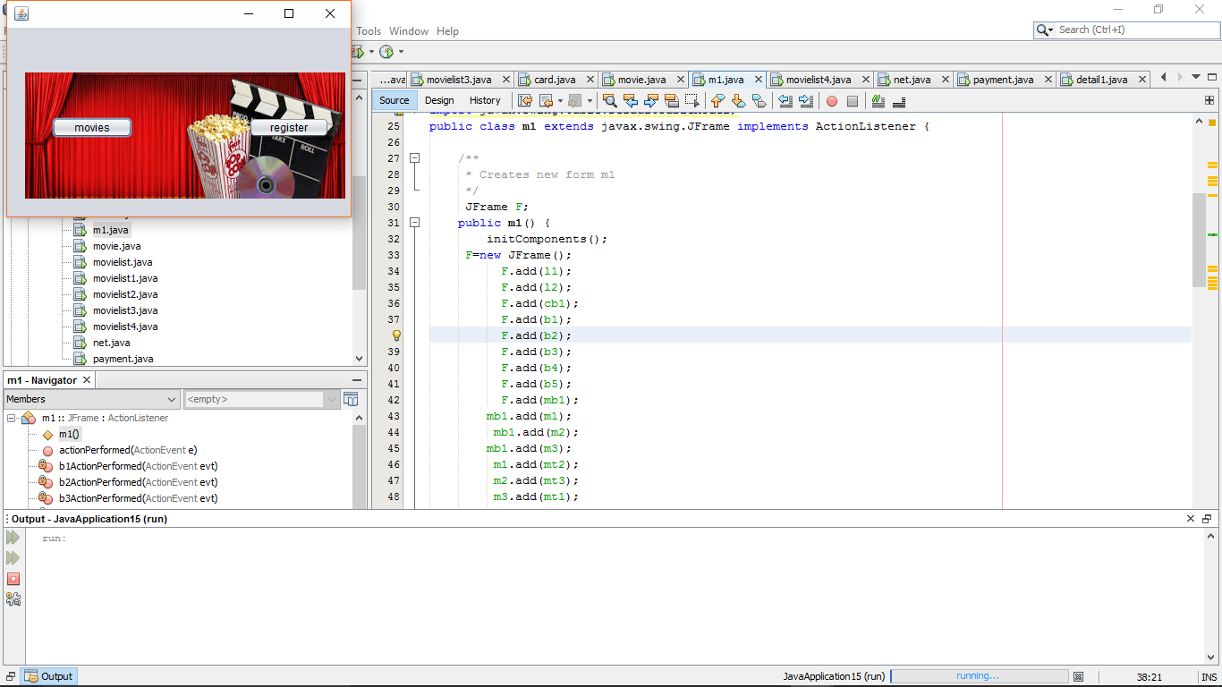

Figure 11 after redirected after clicking back button

* Combo box-:

This is used for the list of the things in this frame I have used for date and year and month

Design



Figure 12 design

The output of this page

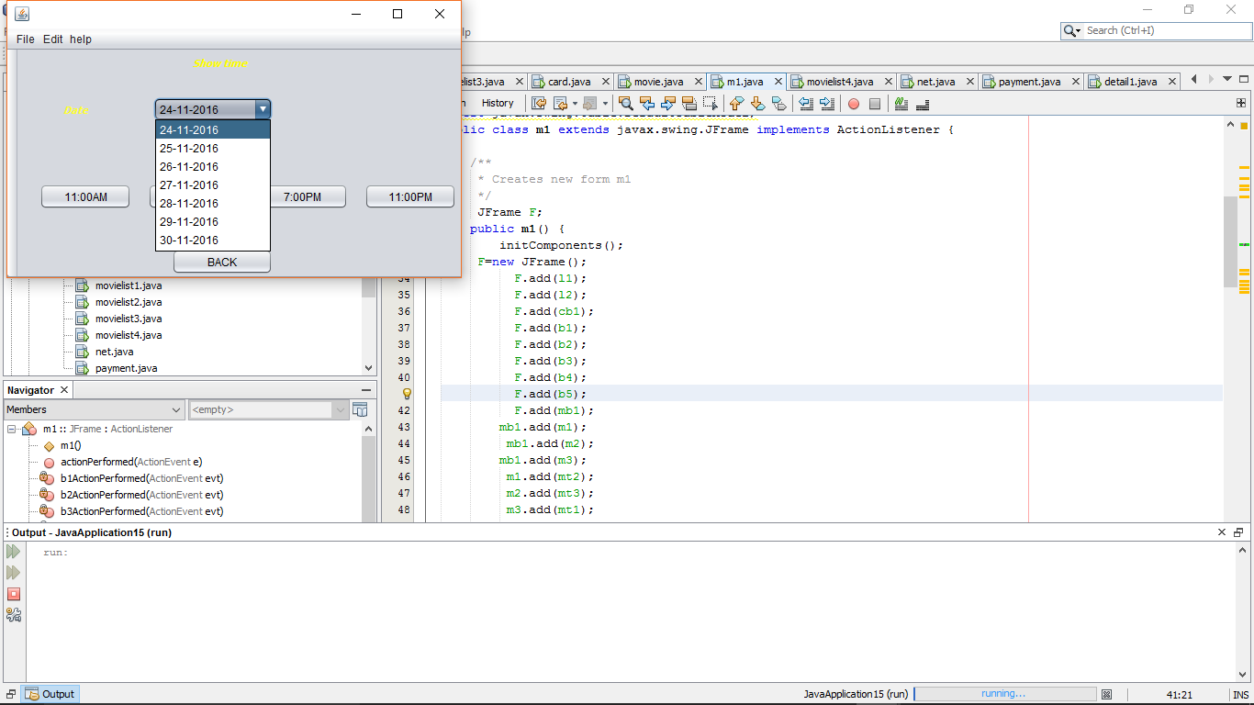

Figure 13 output of selecting date

After selecting the date in list

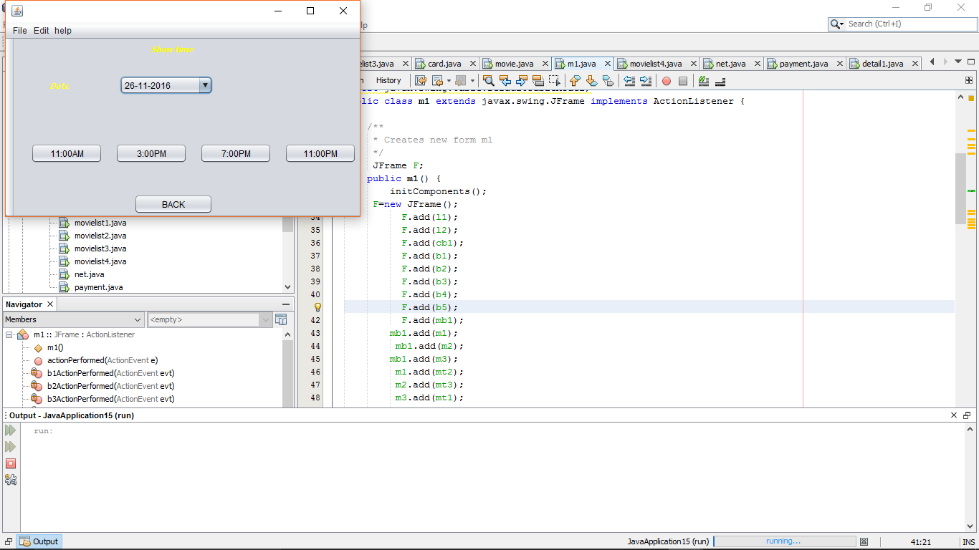

Figure 14 finally the date is selected

* Check box-:

This is used for selecting the multiple things in my frame I have used for seats

Design

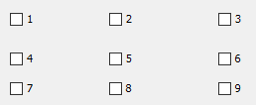

Figure 15 design

The output of the frame

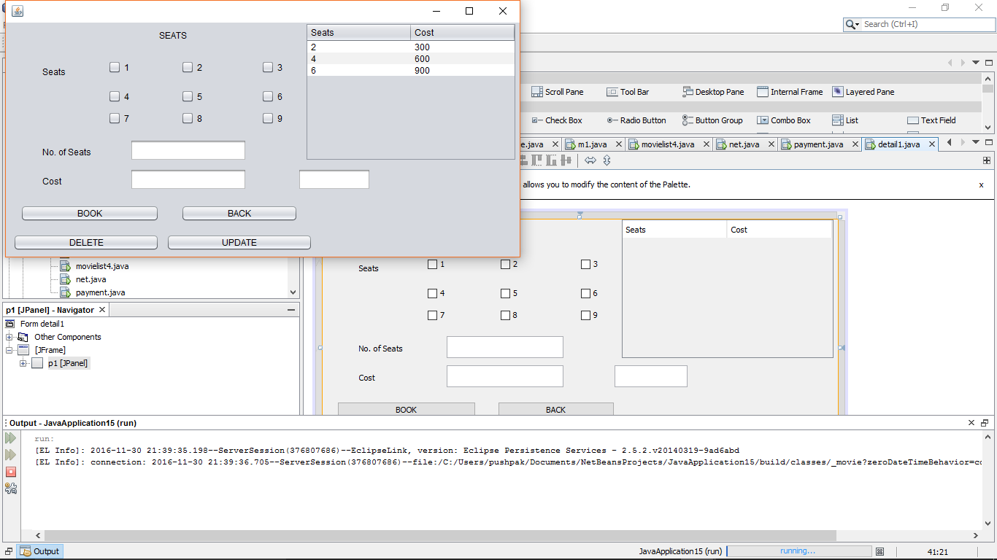

Figure 16 output for seats

After selecting the multiple combo boxes

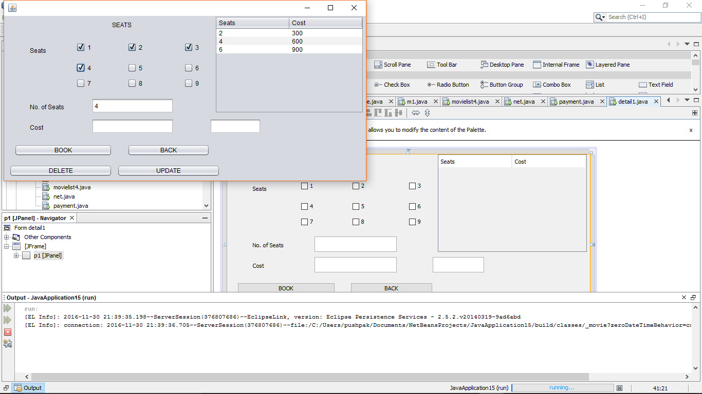

Figure 17 output after selecting

* Menu bar-:

This the bar menu which consists of different menu which is used for selecting particular option

Design



Figure 18 design

The output of the code

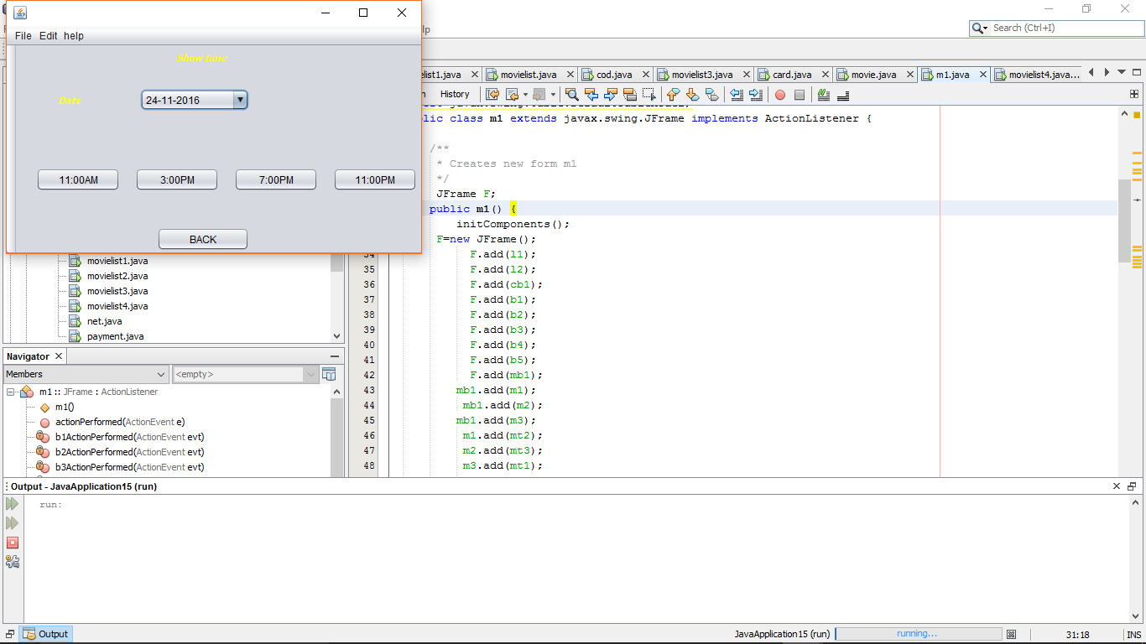

Figure 19 output design

After clicking the help and it show the document in the laptop

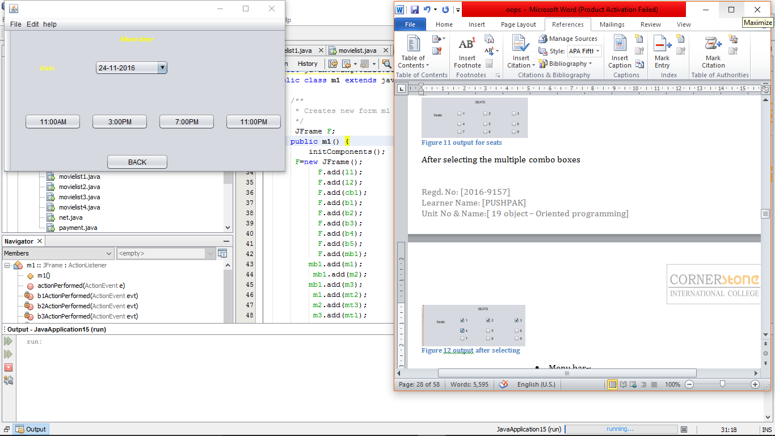

Figure 20 output of the help button

* Popup menu-:

This is menu which is will come after right clicking and it contains many option

Design

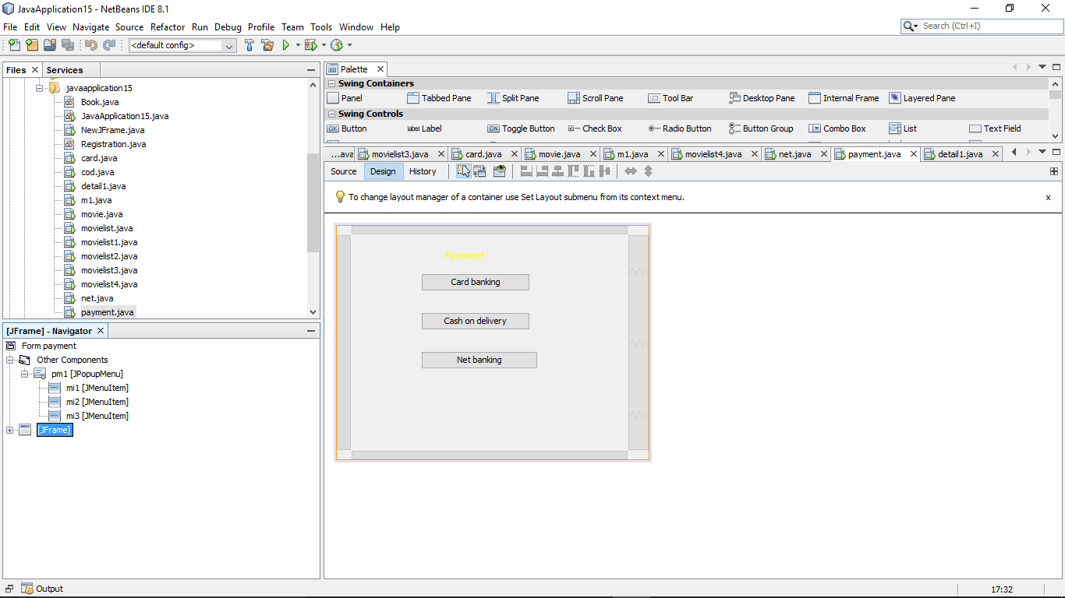

Figure 21 design

After the output is

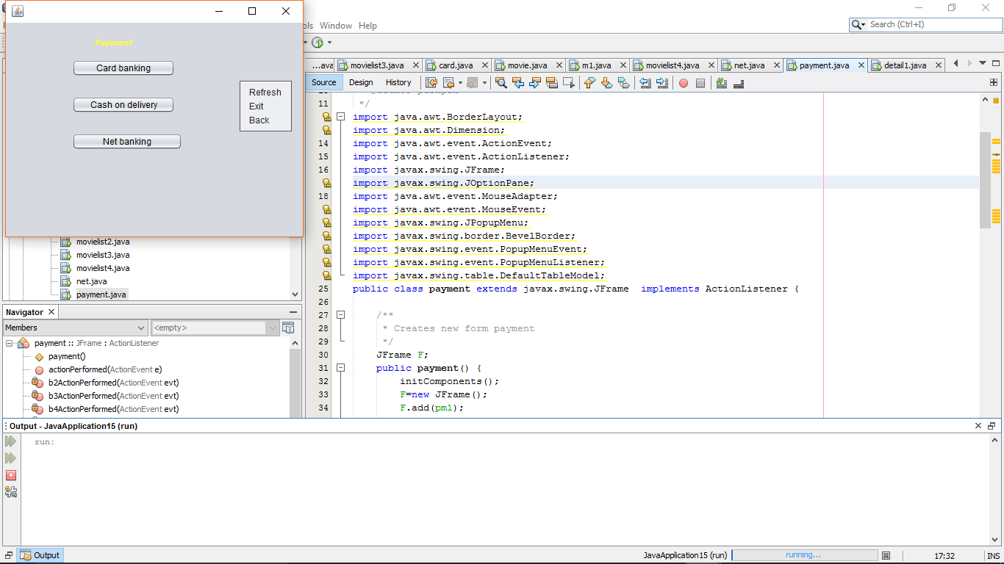

Figure 22 out put of popmenu

After select the refresh it will refresh the same page

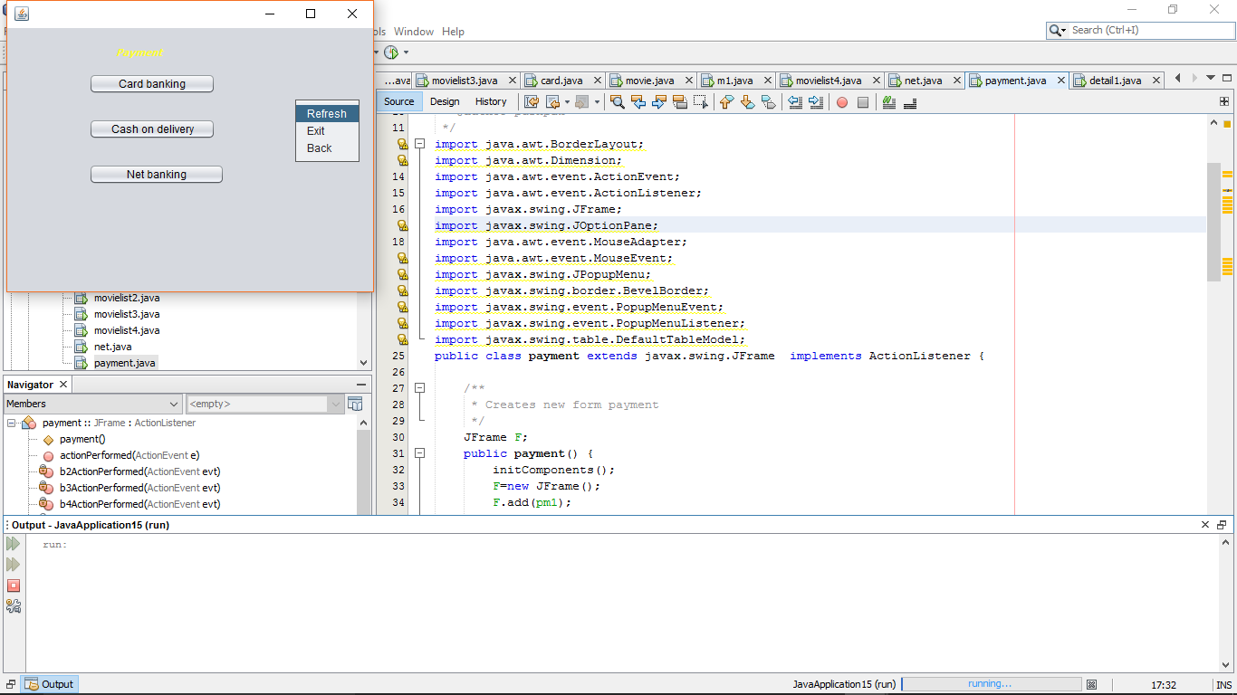

Figure 23 clicking refresh

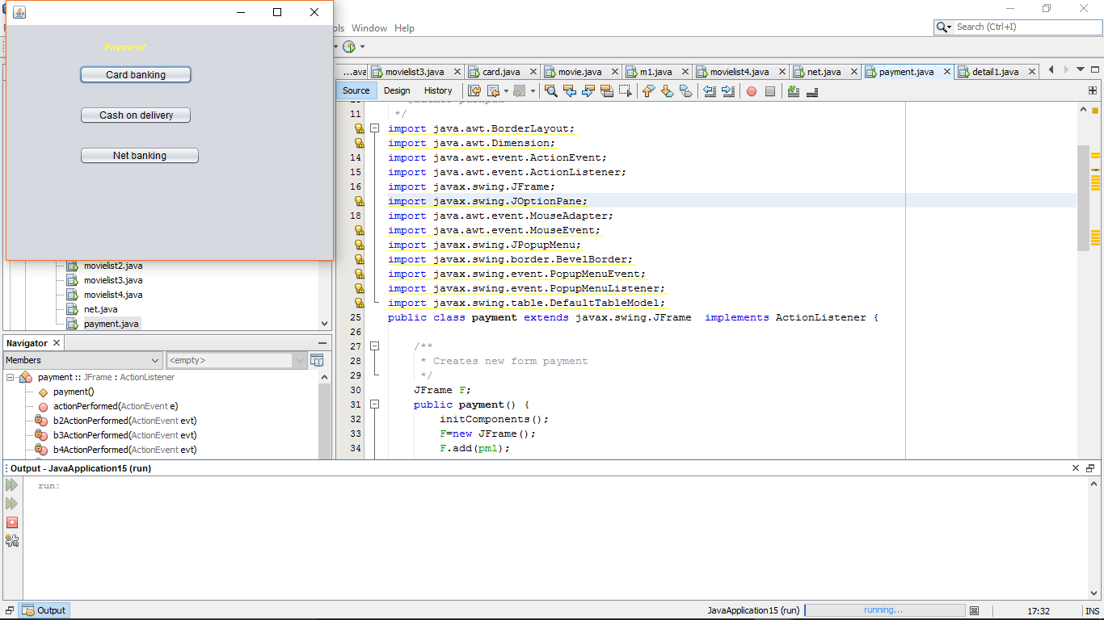

Figure 24 output after clicking it

**Date and time for movie list-:**

In this page I have designed like selecting the date and time for movies for different movies

**Design-:**

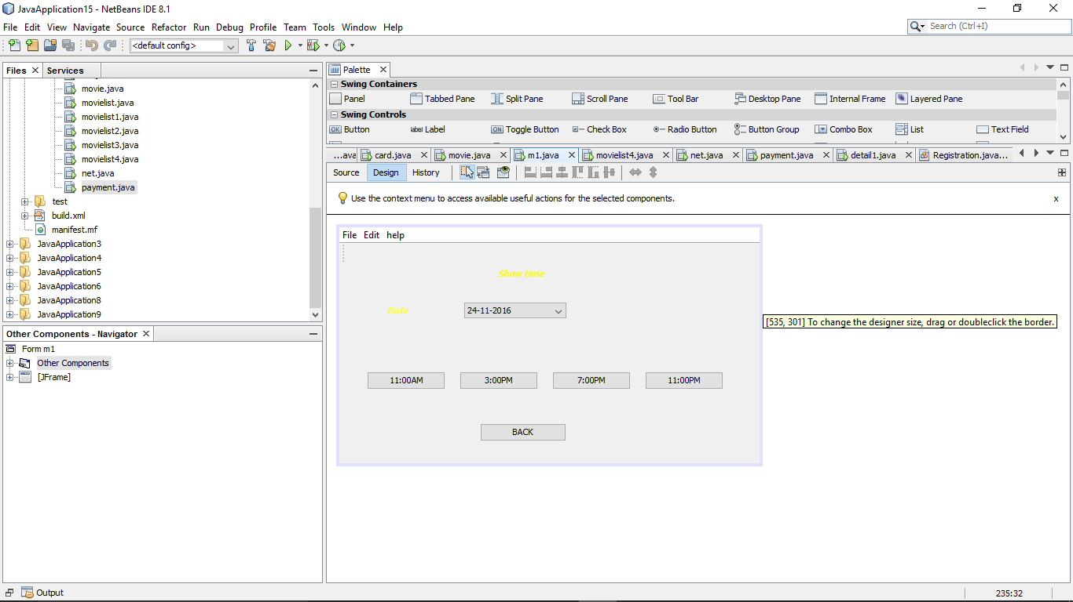

Figure 1 design for show timing and date

**Code for this page-:**

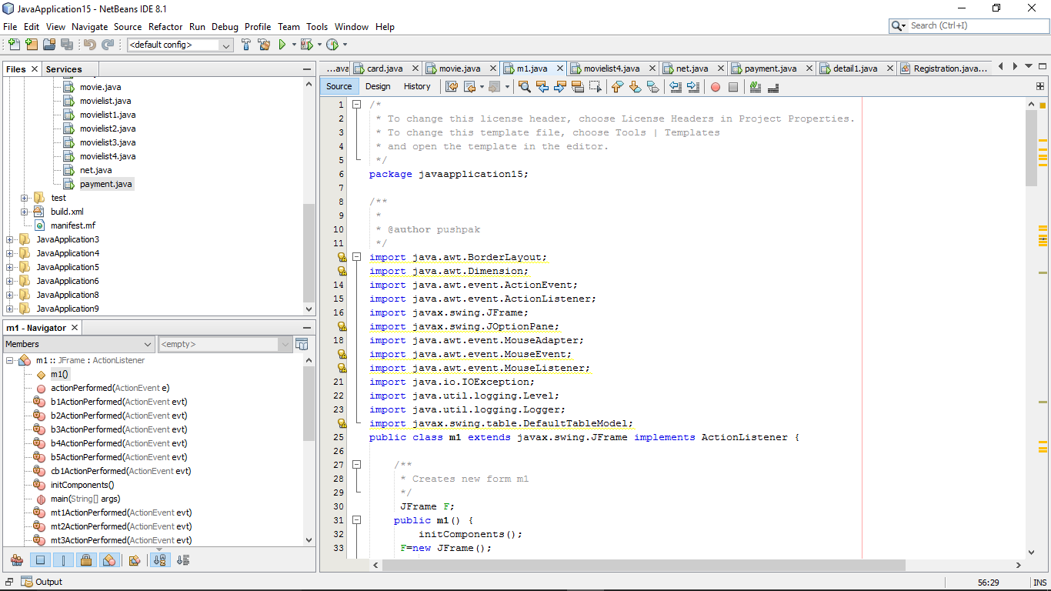

Figure 2 code for show timing and date1

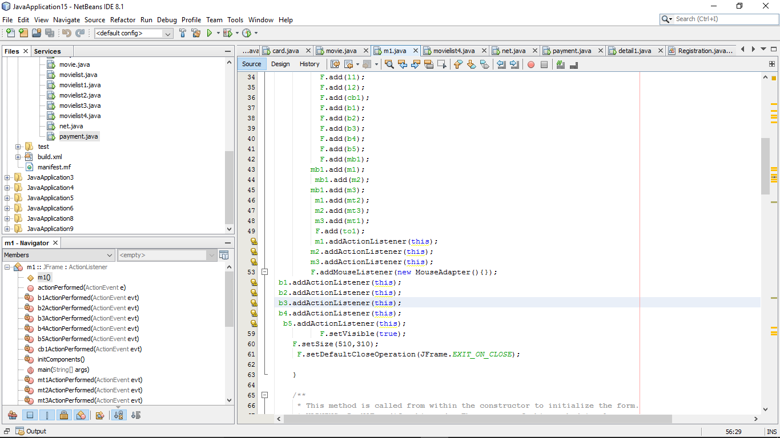

Figure 3 code for show timing and date2

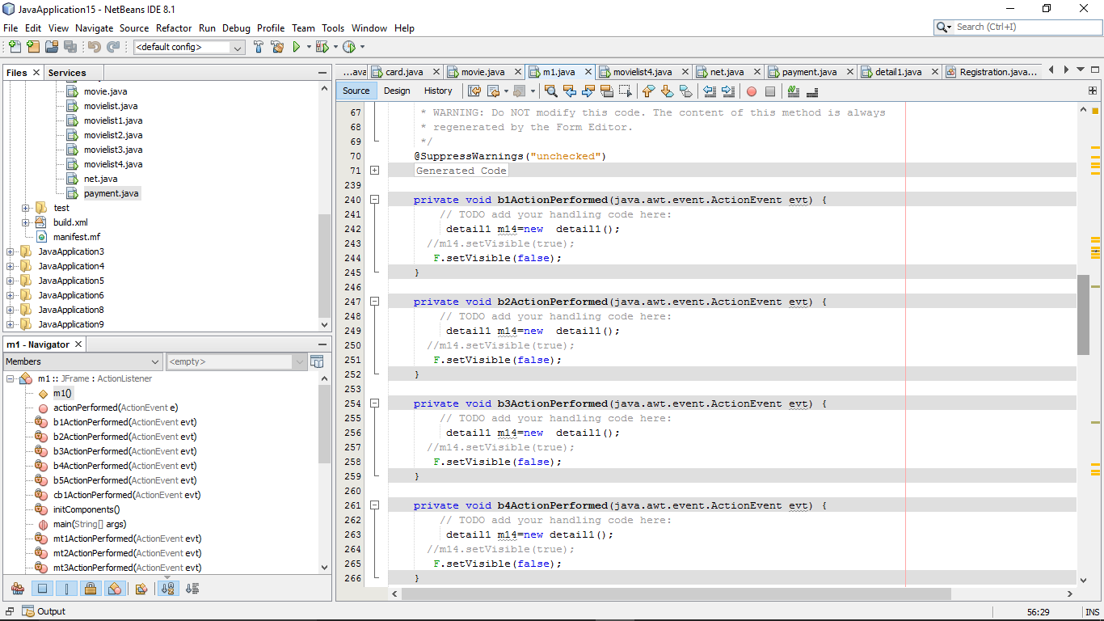

Figure 4 code for show timing and date3

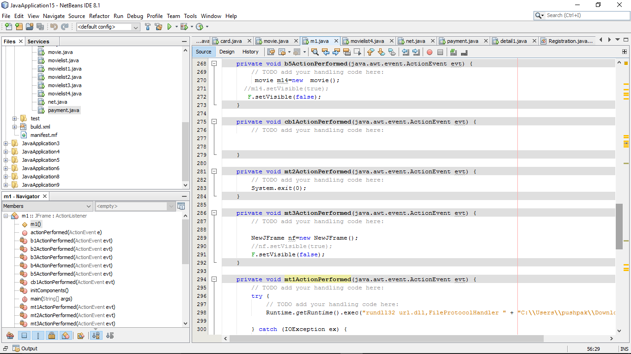

Figure 5 code for show timing and date4

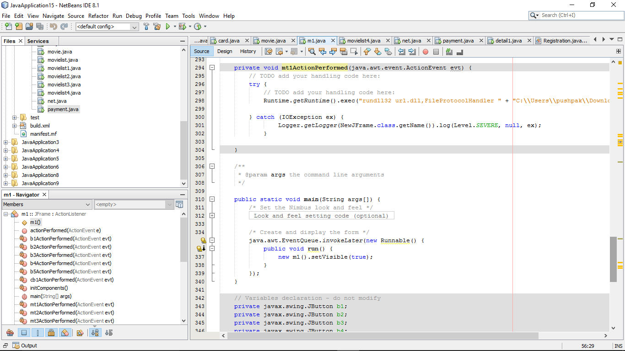

Figure 6 code for show timing and date5

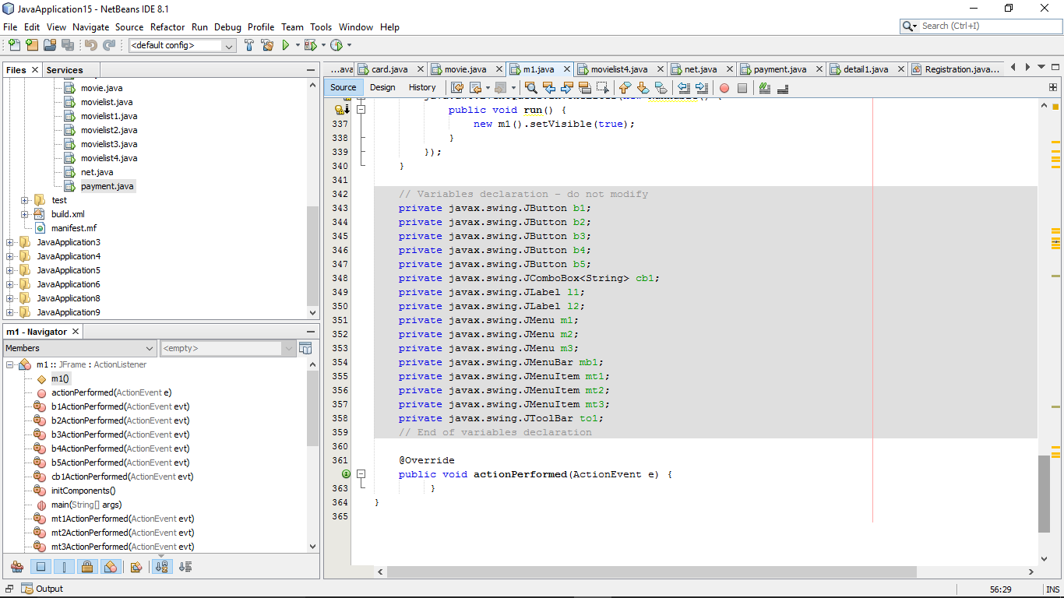

Figure 7 code for show timing and date6

**Output for this-:**

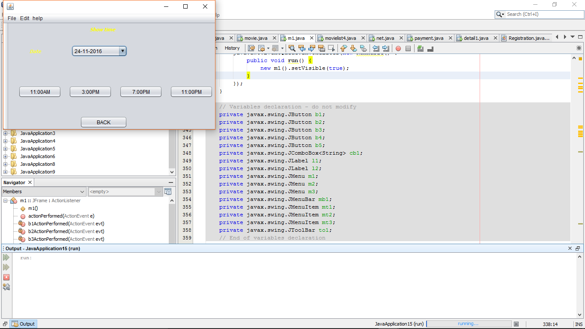

Figure 8 output

**Code explanation-:**

import java.awt.BorderLayout; //used for border lay out

import java.awt.Dimension; //used for setting the dimensions

import java.awt.event.ActionEvent; //used for performing particular button action

import java.awt.event.ActionListener; // used for performing all the action

import javax.swing.JFrame; //used for frame

import javax.swing.JOptionPane; //used for option pane

import java.awt.event.MouseAdapter; //used for mouse adapter

import java.awt.event.MouseEvent; //used for particular mouse event

import java.awt.event.MouseListener; // used for performing the all mouse listener

import java.io.IOException; //used for i/o exception

import java.util.logging.Level; //used for logging level action

import java.util.logging.Logger; //used for logger action

import javax.swing.table.DefaultTableModel; //used for setting default table

public class m1 extends javax.swing.JFrame implements ActionListener {

JFrame F; //used for setting the frame name

public m1() {

initComponents();

F=new JFrame(); //In frame setting the frame in it

F.add(l1); //adding the object to that frame

F.add(l2);

F.add(cb1);

F.add(b1);

F.add(b2);

F.add(b3);

F.add(b4);

F.add(b5);

F.add(mb1);

mb1.add(m1);

mb1.add(m2);

mb1.add(m3);

m1.add(mt2);

m2.add(mt3);

m3.add(mt1);

F.add(to1);

m1.addActionListener(this); //using for add listener this button

m2.addActionListener(this);

m3.addActionListener(this);

F.addMouseListener(new MouseAdapter(){}); //used for adding mouse listener

b1.addActionListener(this);

b2.addActionListener(this);

b3.addActionListener(this);

b4.addActionListener(this);

b5.addActionListener(this);

F.setVisible(true); //used for visible code

F.setSize(510,310); //used for setting of frame code

F.setDefaultCloseOperation(JFrame.EXIT_ON_CLOSE); //used for setting closing the frame

}

private void b1ActionPerformed(java.awt.event.ActionEvent evt) {

// TODO add your handling code here:

detail1 m14=new detail1(); //used for redirecting for next frame

//m14.setVisible(true);

F.setVisible(false); //used visible of upper frame

}

private void b2ActionPerformed(java.awt.event.ActionEvent evt) {

// TODO add your handling code here:

detail1 m14=new detail1();

//m14.setVisible(true);

F.setVisible(false);

}

private void b3ActionPerformed(java.awt.event.ActionEvent evt) {

// TODO add your handling code here:

detail1 m14=new detail1();

//m14.setVisible(true);

F.setVisible(false);

}

private void b4ActionPerformed(java.awt.event.ActionEvent evt) {

// TODO add your handling code here:

detail1 m14=new detail1();

//m14.setVisible(true);

F.setVisible(false);

}

private void b5ActionPerformed(java.awt.event.ActionEvent evt) {

// TODO add your handling code here:

movie m14=new movie();

//m14.setVisible(true);

F.setVisible(false);

}

private void mt2ActionPerformed(java.awt.event.ActionEvent evt) {

// TODO add your handling code here:

System.exit(0); //used for closing the frame

}

private void mt3ActionPerformed(java.awt.event.ActionEvent evt) {

// TODO add your handling code here:

NewJFrame nf=new NewJFrame();

//nf.setVisible(true);

F.setVisible(false);

}

private void mt1ActionPerformed(java.awt.event.ActionEvent evt) {

// TODO add your handling code here:

try {

// TODO add your handling code here:

Runtime.getRuntime().exec("rundll32 url.dll,FileProtocolHandler " + "C:\\Users\\pushpak\\Downloads\\oops.docx\\" ); //used for bring the file from the place the computer or any place

} catch (IOException ex) { //used for bring the io exception

Logger.getLogger(NewJFrame.class.getName()).log(Level.SEVERE, null, ex);

}

}

**Seats and price-:**

In this page no of seats and price of selected movie in the page and used for booking details

**Design -:**

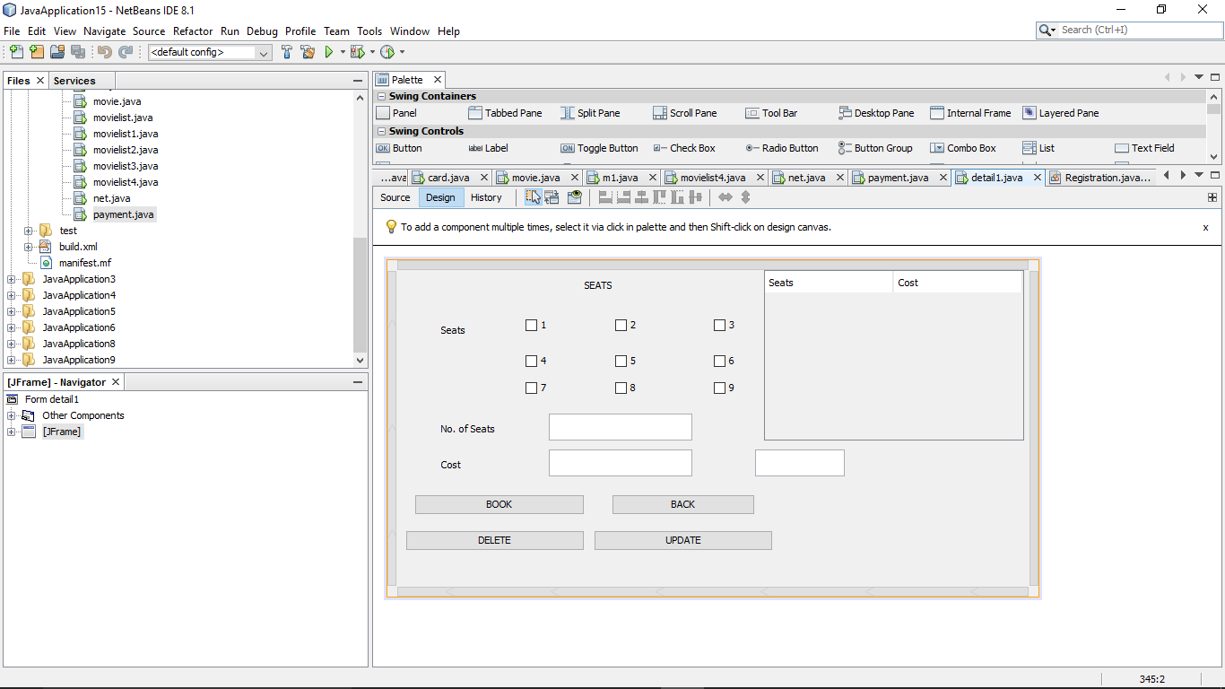

Figure 9 design for seat and price

**Code-:**

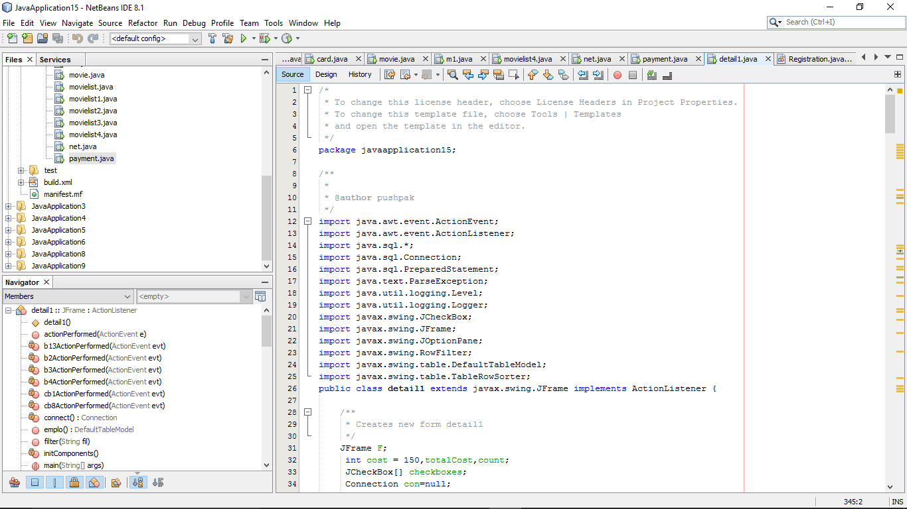

Figure 10 seats and price1

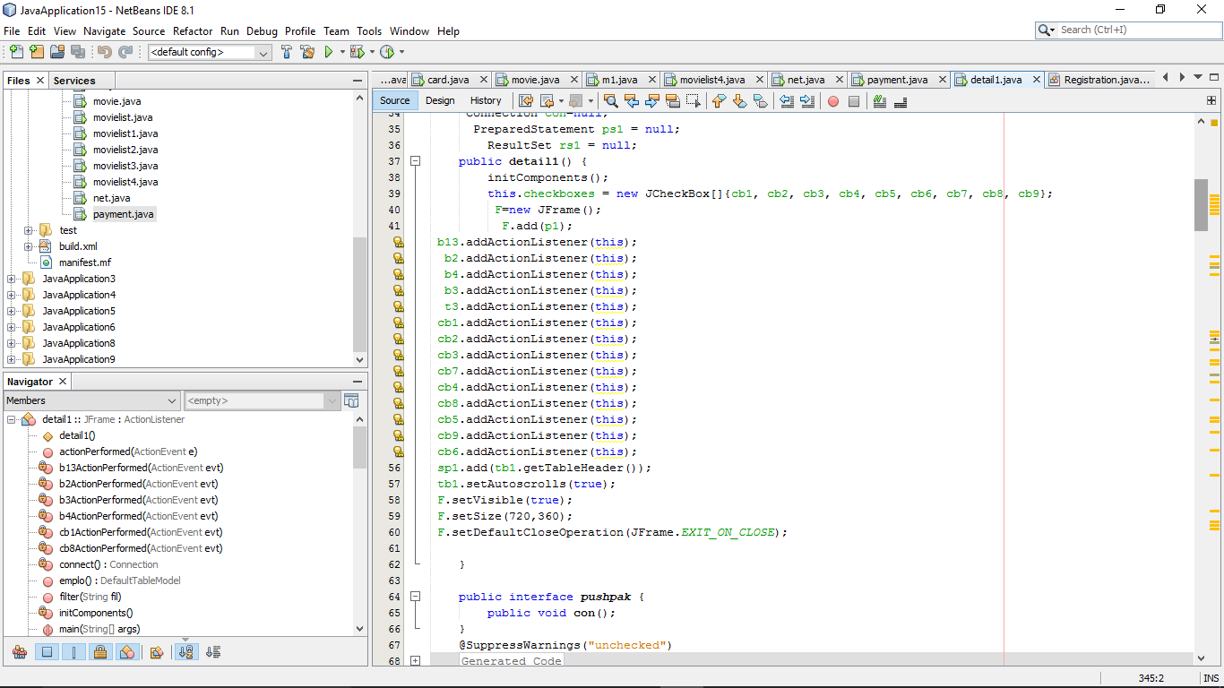

Figure 11 seats and price2

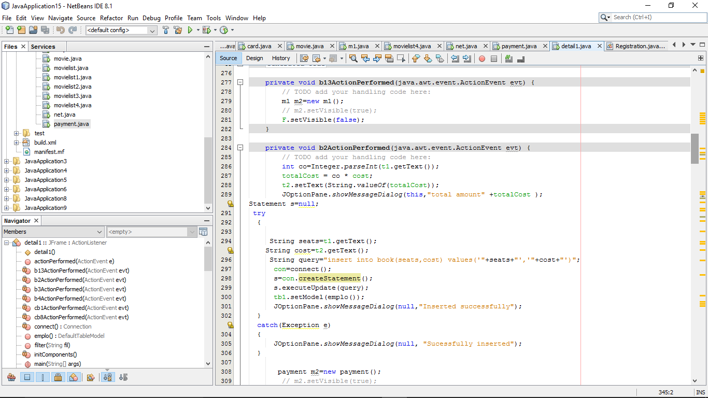

Figure 12 seats and price3

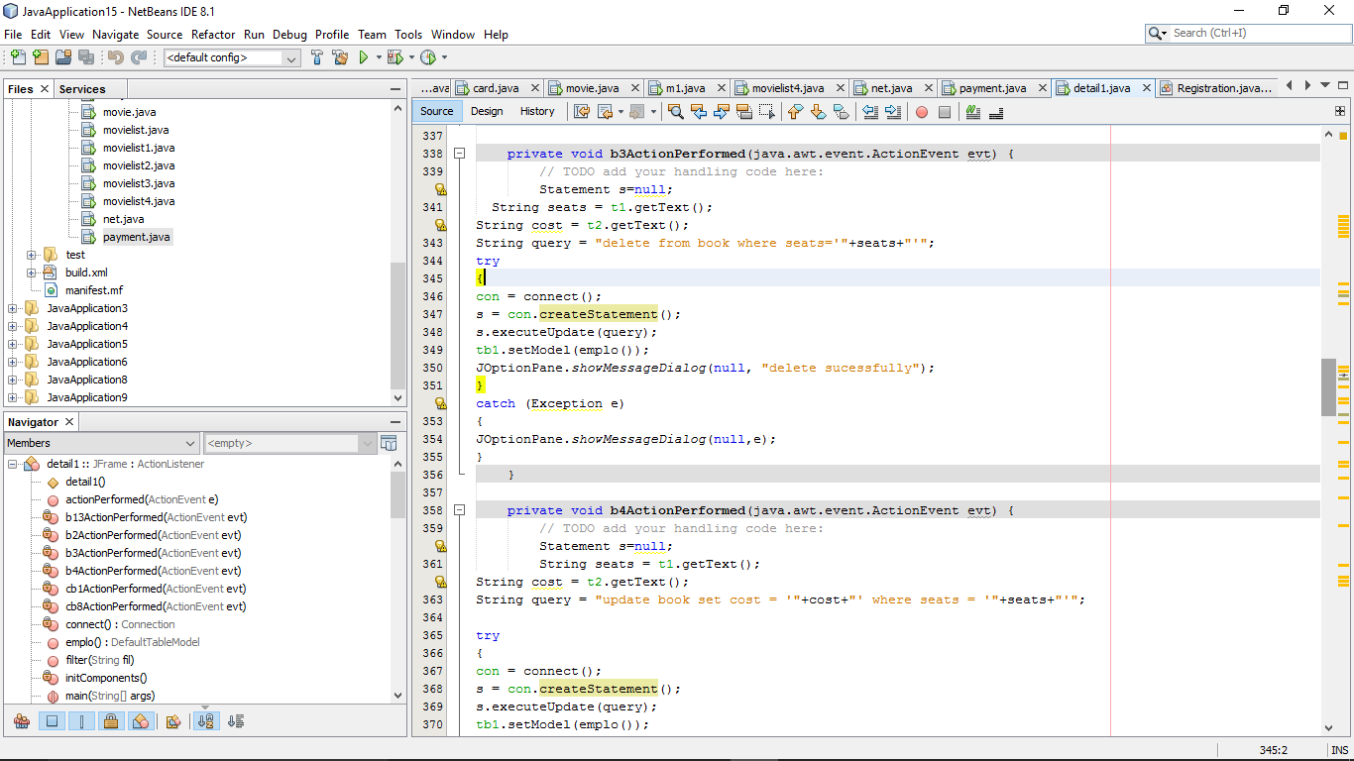

Figure 13 seats and price4

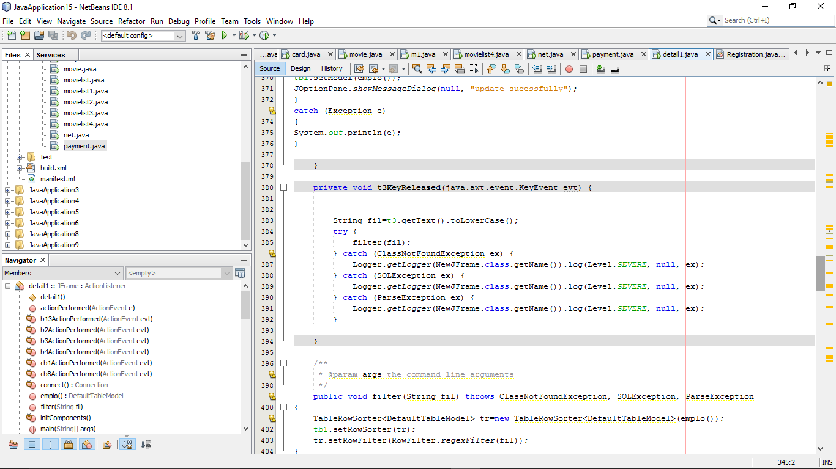

Figure 14 seats and price5

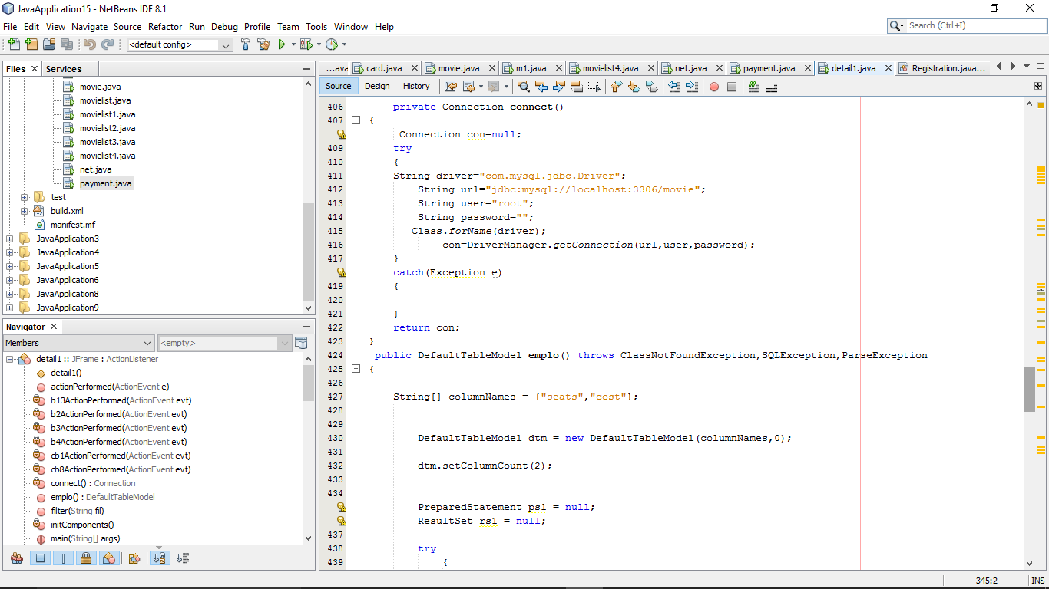

Figure 15 seats and price6

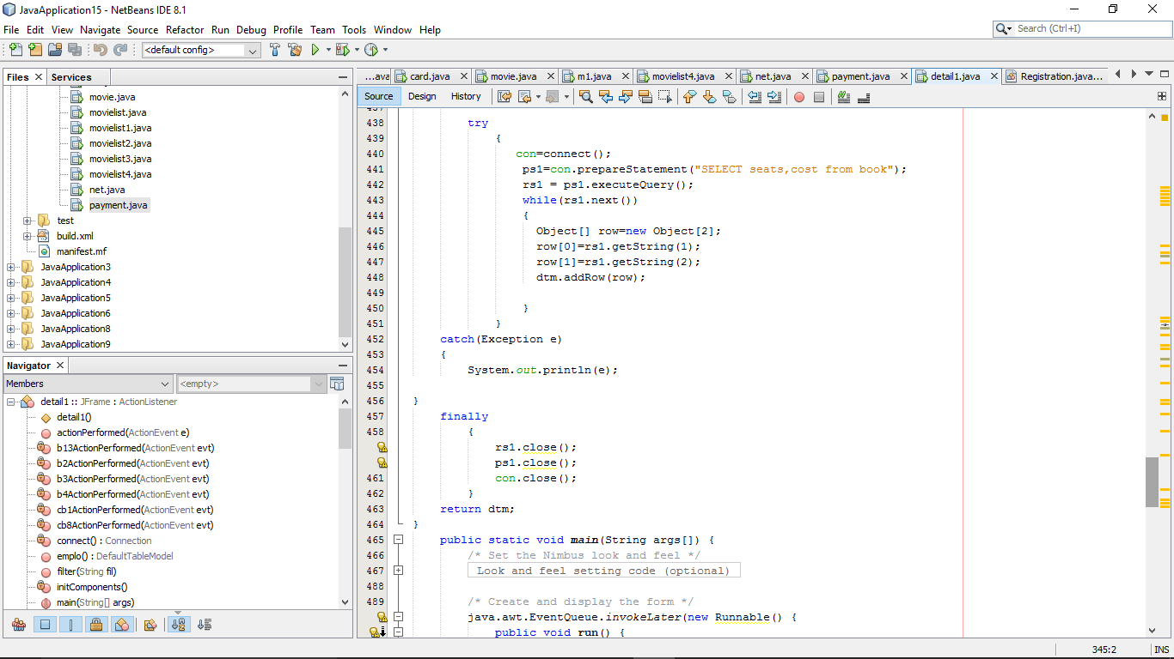

Figure 16 seats and price7

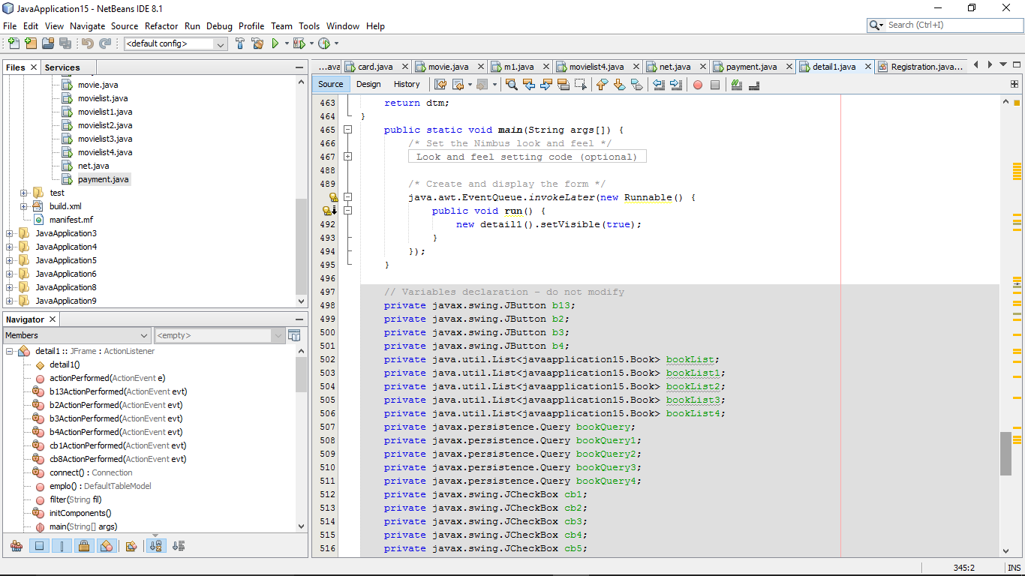

Figure 17 seats and price8

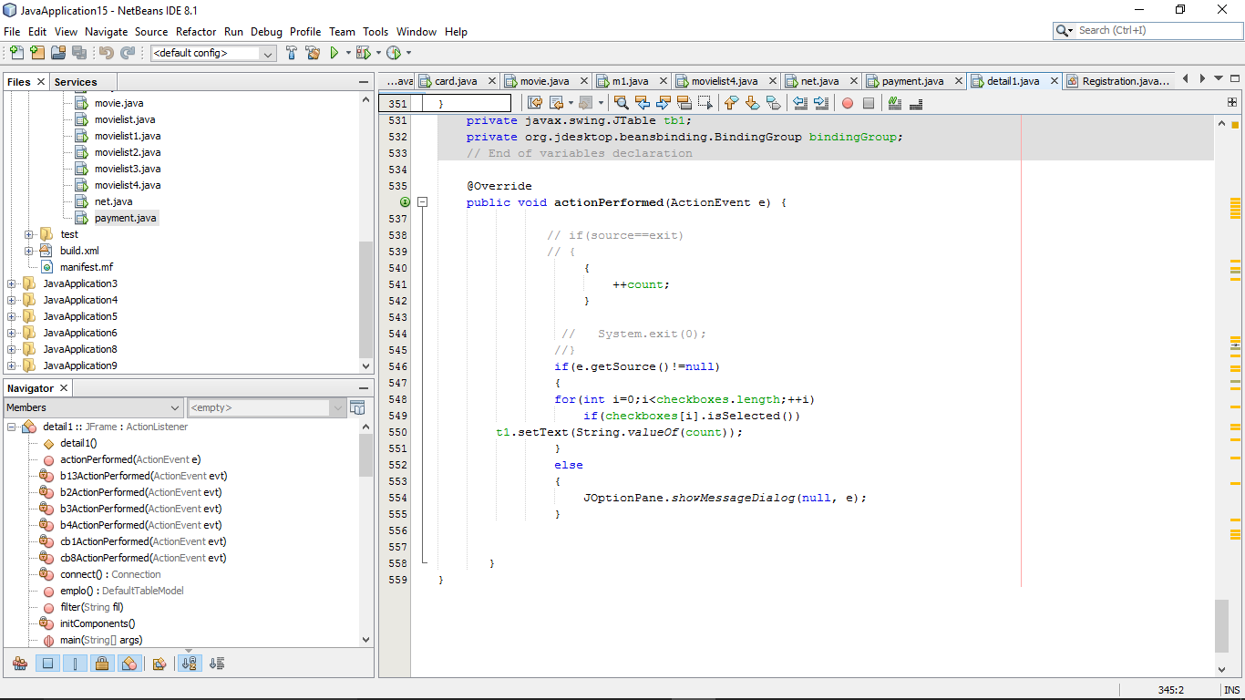

Figure 18 seats and price9

**Output-:**

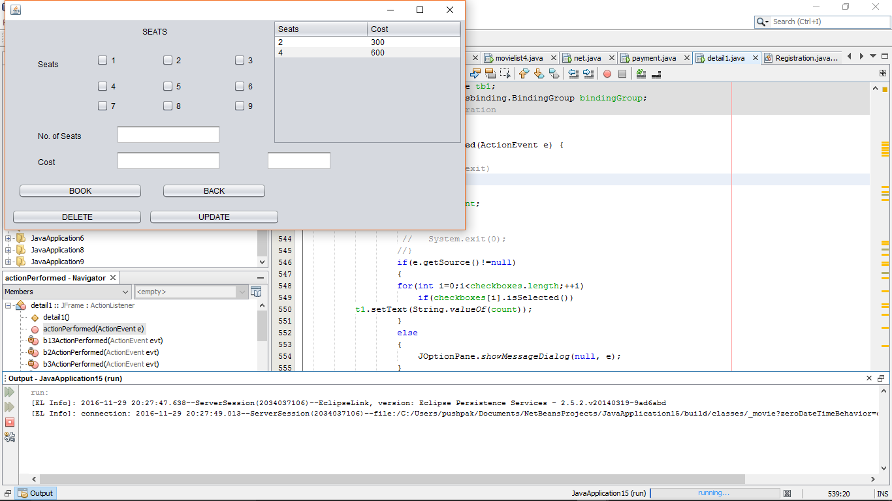

Figure 19 seats and price output

**Code explanation-:**

import java.awt.event.ActionEvent;

import java.awt.event.ActionListener;

import java.sql.*; //used for sql

import java.sql.Connection; //used for sql conncetion

import java.sql.PreparedStatement; //used for sql prepared statement

import java.text.ParseException; //used for parse exception

import java.util.logging.Level;

import java.util.logging.Logger;

import javax.swing.JCheckBox; //used for check box

import javax.swing.JFrame;

import javax.swing.JOptionPane; //used for option pane

import javax.swing.RowFilter; //used for row filter

import javax.swing.table.DefaultTableModel;

import javax.swing.table.TableRowSorter; //used for table row sorted

public class detail1 extends javax.swing.JFrame implements ActionListener {

JFrame F;

int cost = 150,totalCost,count; //used for cost and counting

JCheckBox[] checkboxes; //used for selecting checkbox

Connection con=null; //used for connection null

PreparedStatement ps1 = null; used for prepared statement null

ResultSet rs1 = null; //used for setting result set null

public detail1() {

initComponents();

this.checkboxes = new JCheckBox[]{cb1, cb2, cb3, cb4, cb5, cb6, cb7, cb8, cb9};

F=new JFrame();

F.add(p1);

b13.addActionListener(this);

b2.addActionListener(this);

b4.addActionListener(this);

b3.addActionListener(this);

t3.addActionListener(this);

cb1.addActionListener(this);

cb2.addActionListener(this);

cb3.addActionListener(this); //used for adding the listener for this button

cb7.addActionListener(this);

cb4.addActionListener(this);

cb8.addActionListener(this);

cb5.addActionListener(this);

cb9.addActionListener(this);

cb6.addActionListener(this);

sp1.add(tb1.getTableHeader()); //used for get table header

tb1.setAutoscrolls(true); //used for setting scrollpanel

F.setVisible(true);

F.setSize(720,360);

F.setDefaultCloseOperation(JFrame.EXIT_ON_CLOSE);

}

private void b13ActionPerformed(java.awt.event.ActionEvent evt) {

// TODO add your handling code here:

m1 m2=new m1();

// m2.setVisible(true);

F.setVisible(false);

}

private void b2ActionPerformed(java.awt.event.ActionEvent evt) {

// TODO add your handling code here:

int co=Integer.parseInt(t1.getText()); //used for counting the number

totalCost = co * cost; //used for total cost

t2.setText(String.valueOf(totalCost)); //used for getting total cost

JOptionPane.showMessageDialog(this,"total amount" +totalCost );

Statement s=null; //used for setting null statement

try

{

String seats=t1.getText(); //used for bring data from the text box

String cost=t2.getText();

String query="insert into book(seats,cost) values('"+seats+"','"+cost+"')"; //used for inserting the data in the particular place

con=connect();

s=con.createStatement();

s.executeUpdate(query); //used for executing the query

tb1.setModel(emplo());

JOptionPane.showMessageDialog(null,"Inserted successfully");

}

catch(Exception e)

{

JOptionPane.showMessageDialog(null, "Sucessfully inserted");

}

payment m2=new payment();

// m2.setVisible(true);

F.setVisible(false);

}

private void b3ActionPerformed(java.awt.event.ActionEvent evt) {

// TODO add your handling code here:

Statement s=null;

String seats = t1.getText();

String cost = t2.getText();

String query = "delete from book where seats='"+seats+"'"; //used for delete the row

try

{

con = connect();

s = con.createStatement();

s.executeUpdate(query);

tb1.setModel(emplo());

JOptionPane.showMessageDialog(null, "delete sucessfully");

}

catch (Exception e)

{

JOptionPane.showMessageDialog(null,e);

}

}

private void b4ActionPerformed(java.awt.event.ActionEvent evt) {

// TODO add your handling code here:

Statement s=null;

String seats = t1.getText();

String cost = t2.getText();

String query = "update book set cost = '"+cost+"' where seats = '"+seats+"'"; //used for updating the table

try

{

con = connect();

s = con.createStatement();

s.executeUpdate(query);

tb1.setModel(emplo());

JOptionPane.showMessageDialog(null, "update sucessfully");

}

catch (Exception e)

{

System.out.println(e);

}

}

private void t3KeyReleased(java.awt.event.KeyEvent evt) {

String fil=t3.getText().toLowerCase(); //used for getting the details from the table

try {

filter(fil);

} catch (ClassNotFoundException ex) {

Logger.getLogger(NewJFrame.class.getName()).log(Level.SEVERE, null, ex);

} catch (SQLException ex) {

Logger.getLogger(NewJFrame.class.getName()).log(Level.SEVERE, null, ex);

} catch (ParseException ex) {

Logger.getLogger(NewJFrame.class.getName()).log(Level.SEVERE, null, ex);

}

}

public void filter(String fil) throws ClassNotFoundException, SQLException, ParseException

{

TableRowSorter<DefaultTableModel> tr=new //used for setting the details in the table in particular row

TableRowSorter<DefaultTableModel>(emplo());

tb1.setRowSorter(tr);

tr.setRowFilter(RowFilter.regexFilter(fil));

}

private Connection connect()

{

Connection con=null;

try

{

String driver="com.mysql.jdbc.Driver"; //used for driver connection

String url="jdbc:mysql://localhost:3306/movie"; //used for connecting the particular database

String user="root";

String password="";

Class.forName(driver);

con=DriverManager.getConnection(url,user,password); //used for connecting the particular thing

}

catch(Exception e)

{

}

return con;

}

public DefaultTableModel emplo() throws ClassNotFoundException,SQLException,ParseException

{

String[] columnNames = {"seats","cost"}; //used for setting the particular column

DefaultTableModel dtm = new DefaultTableModel(columnNames,0);

dtm.setColumnCount(2); //used for setting the columns

PreparedStatement ps1 = null;

ResultSet rs1 = null;

try

{

con=connect();

ps1=con.prepareStatement("SELECT seats,cost from book"); //used for selecting the table names

rs1 = ps1.executeQuery();

while(rs1.next())

{

Object[] row=new Object[2]; //used for setting the data in the particular column in table

row[0]=rs1.getString(1);

row[1]=rs1.getString(2);

dtm.addRow(row);

}

}

catch(Exception e)

{

System.out.println(e);

}

finally

{

rs1.close();

ps1.close();

con.close();

}

return dtm;

}

{

++count; //used for counting the cost

}

if(e.getSource()!=null)

{

for(int i=0;i<checkboxes.length;++i)

if(checkboxes[i].isSelected())

t1.setText(String.valueOf(count)); //used for getting the counted cost in textbox

}

else

{

JOptionPane.showMessageDialog(null, e);

}

**Payment page-:**

This option is used for the payment of the tickets for selected seats and used for reserving the seats

**Design net beans-:**

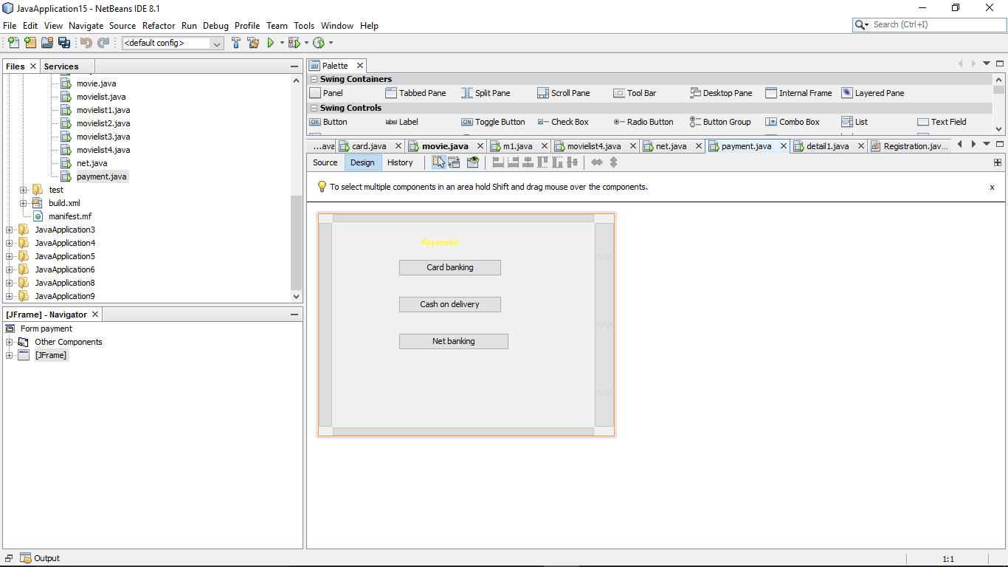

Figure 20 design of payment page

**Code for this page-:**

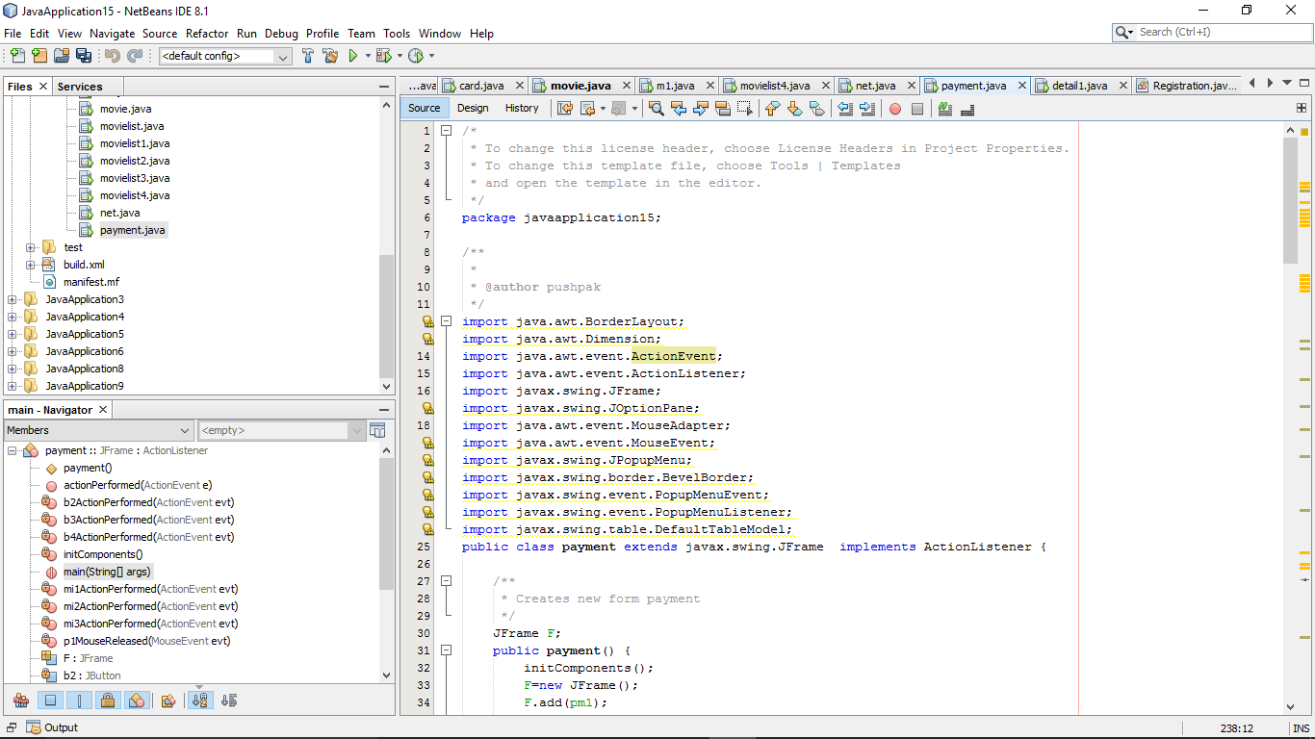

Figure 81 code for payment1

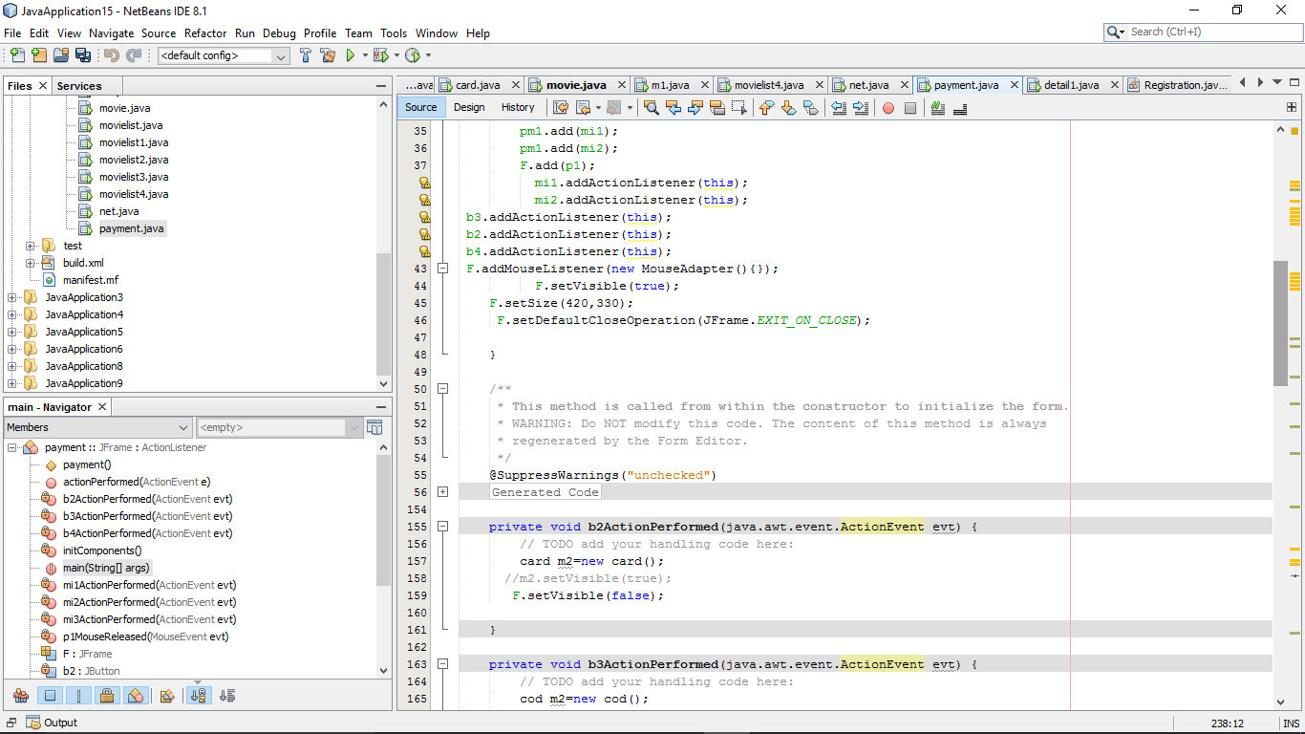

Figure 22 code for payment2

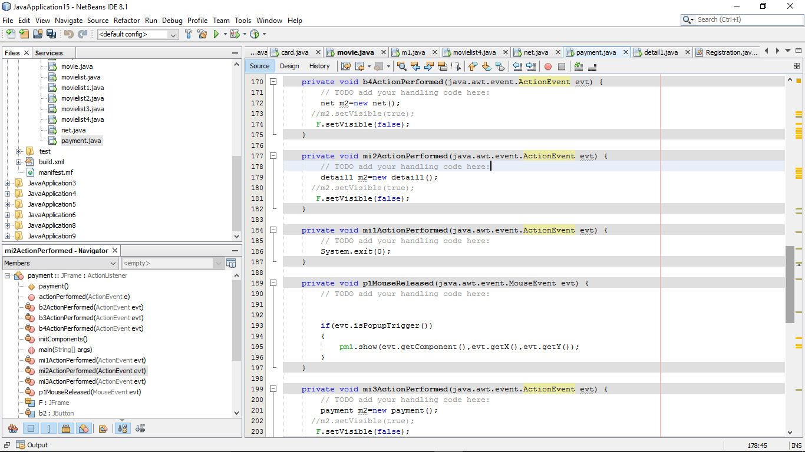

Figure 23 code for payment3

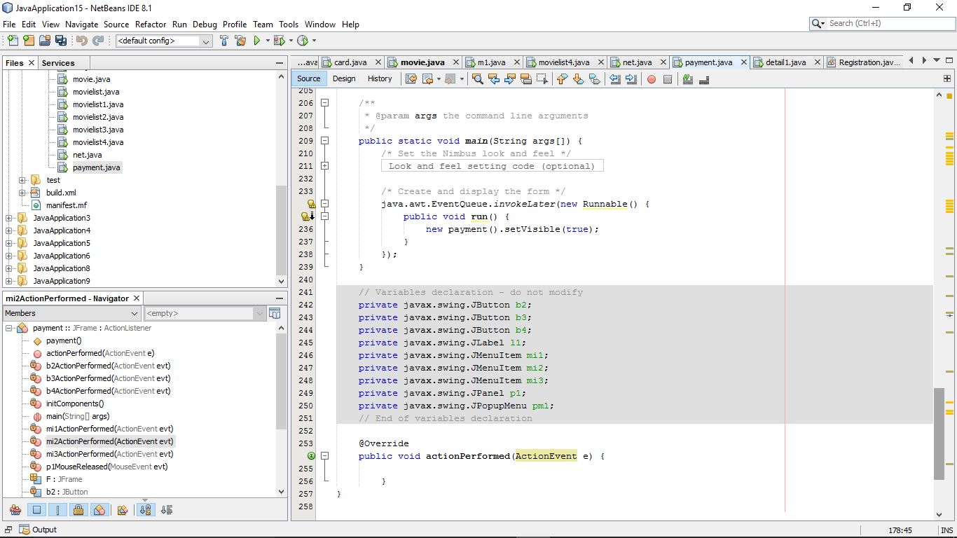

Figure 24 code for payment4

**Output of this page is-:**

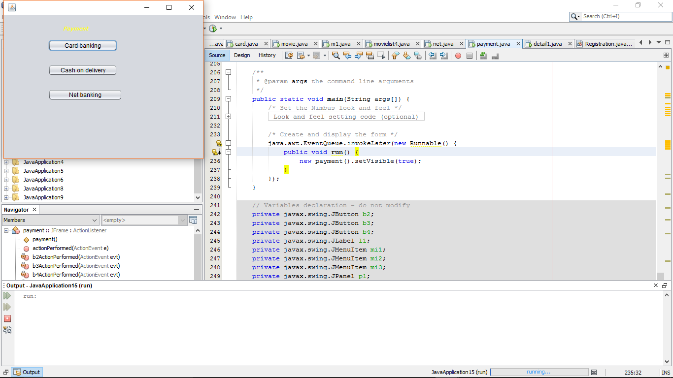

Figure 25 output

**Code explanation-:**

import java.awt.BorderLayout;

import java.awt.Dimension;

import java.awt.event.ActionEvent;

import java.awt.event.ActionListener;

import javax.swing.JFrame;

import javax.swing.JOptionPane;

import java.awt.event.MouseAdapter;

import java.awt.event.MouseEvent;

import javax.swing.JPopupMenu;

import javax.swing.border.BevelBorder;

import javax.swing.event.PopupMenuEvent;

import javax.swing.event.PopupMenuListener;

import javax.swing.table.DefaultTableModel;

public class payment extends javax.swing.JFrame implements ActionListener {

JFrame F;

public payment() {

initComponents();

F=new JFrame();

F.add(pm1);

pm1.add(mi1);

pm1.add(mi2);

F.add(p1);

mi1.addActionListener(this);

mi2.addActionListener(this); //used for add the action

b3.addActionListener(this);

b2.addActionListener(this);

b4.addActionListener(this);

F.addMouseListener(new MouseAdapter(){}); //used for adding the mouse adapter

F.setVisible(true);

F.setSize(420,330);

F.setDefaultCloseOperation(JFrame.EXIT_ON_CLOSE);

}

private void b2ActionPerformed(java.awt.event.ActionEvent evt) {

// TODO add your handling code here:

card m2=new card(); //used for redirecting to another frame

//m2.setVisible(true);

F.setVisible(false);

}

private void b3ActionPerformed(java.awt.event.ActionEvent evt) {

// TODO add your handling code here:

cod m2=new cod();

//m2.setVisible(true);

F.setVisible(false);

}

private void b4ActionPerformed(java.awt.event.ActionEvent evt) {

// TODO add your handling code here:

net m2=new net();

//m2.setVisible(true);

F.setVisible(false);

}

private void mi2ActionPerformed(java.awt.event.ActionEvent evt) {

// TODO add your handling code here:

detail1 m2=new detail1();

//m2.setVisible(true);

F.setVisible(false);

}

private void mi1ActionPerformed(java.awt.event.ActionEvent evt) {

// TODO add your handling code here:

System.exit(0); //used for exit the all application

}

private void p1MouseReleased(java.awt.event.MouseEvent evt) {

// TODO add your handling code here:

if(evt.isPopupTrigger()) //used for setting the popup trigger

{

pm1.show(evt.getComponent(),evt.getX(),evt.getY()); //used for showing the particular components of popup menu

}

}

private void mi3ActionPerformed(java.awt.event.ActionEvent evt) {

// TODO add your handling code here:

payment m2=new payment();

//m2.setVisible(true);

F.setVisible(false);

}